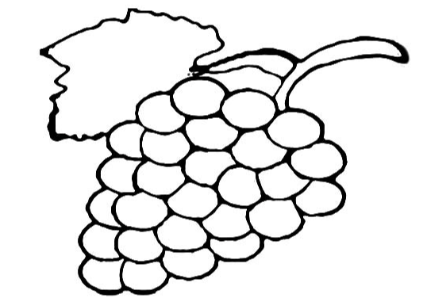

I am the vine, and you are the branches. If you stay joined to me, and I stay joined to you, then you will produce lots of fruit. But you cannot do anything without me.  John 15:5

Our job (the branches) – Stay connected to God through prayer, reading our bibles, spending time with other people who love God and following God’s commandments.

God’s Job (the vine) – To grow us and make us healthy and strong and full of the fruit of His Spirit.